Problem Statement: Stepwise Execution Analysis of Greedy Algorithms

Fractional Knapsack
Theory:

- Compute value-to-weight ratios
  - For each item, calculate value[i] / weight[i] to determine how much profit it gives per unit weight.
- Sort items by efficiency
  - Arrange the items in descending order of their value-to-weight ratio.
  - Ensure that the value, weight, and ratio of each item remain aligned during sorting.
- Initialize profit and capacity tracker
  - Set profit = 0 and remaining capacity = knapsack capacity.
- Iterate through sorted items
  - For each item in order of decreasing ratio:
    - If the item fits completely in the remaining capacity, take it fully and add its value to profit.
    - If the item does not fit completely, take a fraction proportional to the remaining capacity and add the corresponding value to profit.
    - Reduce the remaining capacity accordingly.
- Stop when knapsack is full
  - Continue selecting items until the knapsack’s capacity becomes zero.
- Return the total profit
  - The accumulated profit represents the maximum achievable profit using full and fractional items.
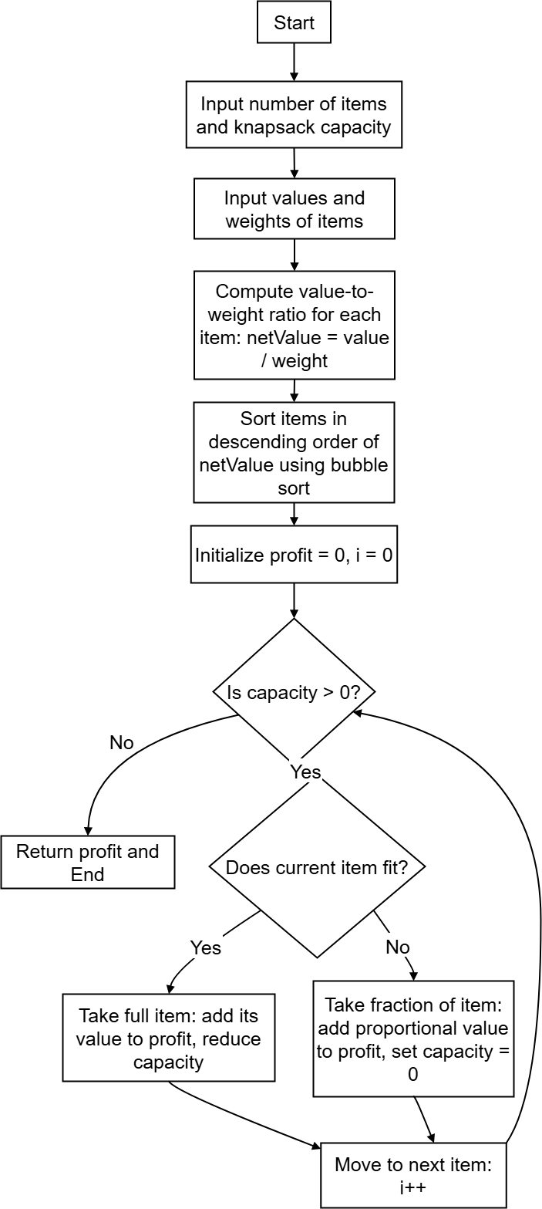
Flow Chart:
Code:
- #include <bits/stdc++.h>
- using namespace std;

- int main() {
- int n, capacity;
- cout << "Enter number of items: ";
- cin >> n;
- cout << "Enter knapsack capacity: ";
- cin >> capacity;

- vector<int> value(n), weight(n);
- vector<double> ratio(n);
- vector<int> idx(n);
- for (int i = 0; i < n; i++)
- idx[i] = i;

- cout << "Enter values: ";
- for (int i = 0; i < n; i++)
- cin >> value[i];

- cout << "Enter weights: ";
- for (int i = 0; i < n; i++)
- cin >> weight[i];

- for (int i = 0; i < n; i++) {
- ratio[i] = (double)value[i] / weight[i];
- }

- sort(idx.begin(), idx.end(), [&](int a, int b) {
- return ratio[a] > ratio[b];
- });

- double profit = 0;
- int rem = capacity;

- cout << "\nSelection Order (Highest ratio first):\n";
- for (int i = 0; i < n && rem > 0; i++) {
- int id = idx[i];
- if (weight[id] <= rem) {
- rem -= weight[id];
- profit += value[id];
- cout << "Item " << (id + 1) << " (full): +" << value[id] << " (w=" << weight[id] << ")\n";
- }
- else {
- double frac = (double)rem / weight[id];
- profit += frac * value[id];
- cout << "Item " << (id + 1) << " (fraction " << rem << "/" << weight[id]
- << "): +" << (int)(frac * value[id]) << "\n";
- rem = 0;
- }
- }

- cout << "\nMaximum Profit = " << (int)profit << endl;
- return 0;
- }
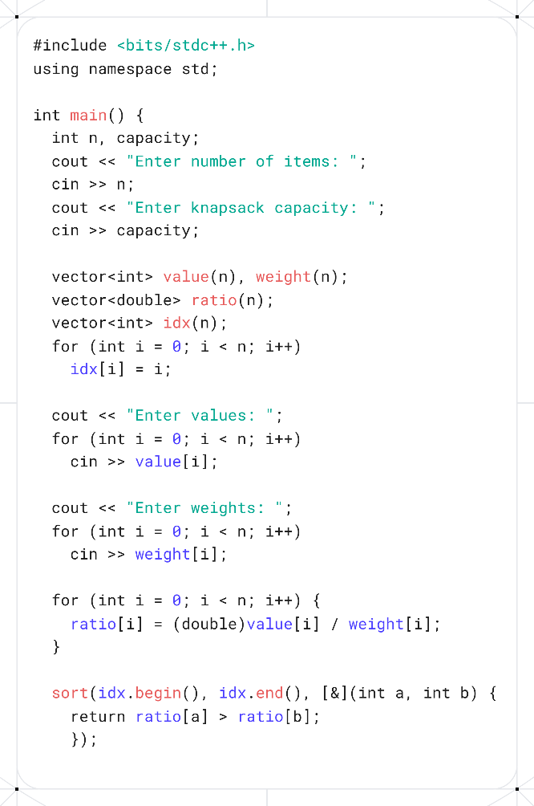
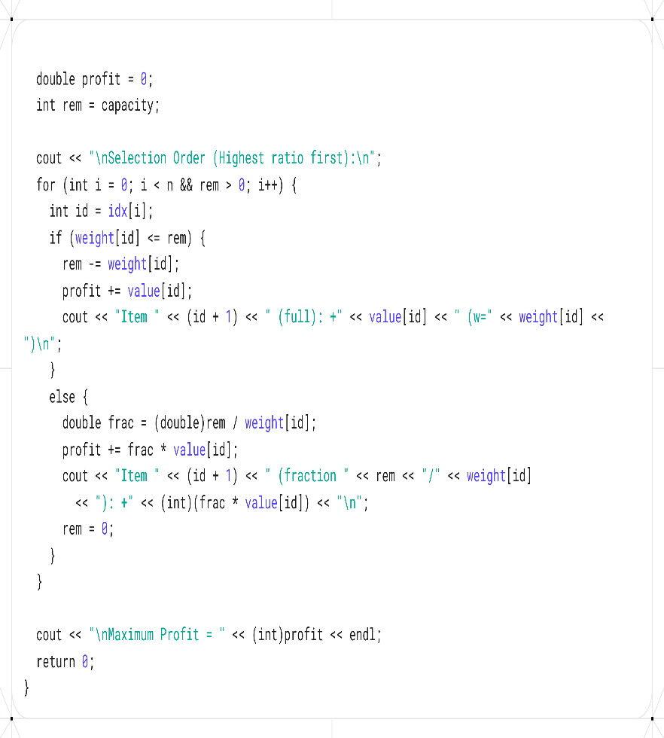
Screenshots:

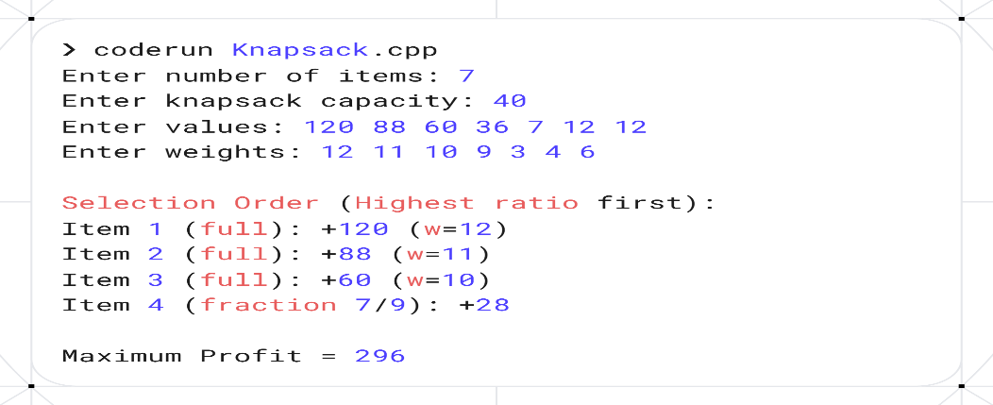

Analysis:
Data Set:
- Number of items: 5
- Knapsack capacity: 20
- Values: 60, 100, 120, 80, 50
- Weights: 10, 20, 30, 10, 5

Stepwise Execution (Greedy Selection by Value/Weight Ratio):
- Compute value-to-weight ratio
  - Item 1 → 60/10 = 6
  - Item 2 → 100/20 = 5
  - Item 3 → 120/30 = 4
  - Item 4 → 80/10 = 8
  - Item 5 → 50/5 = 10
- Sort items by ratio descending
  - Order: Item 5, Item 4, Item 1, Item 2, Item 3
- Select items (greedy)
  - Remaining capacity = 20
  - Item 5 (weight 5) → take full → profit = 50 → remaining capacity = 15
  - Item 4 (weight 10) → take full → profit = 50 + 80 = 130 → remaining capacity = 5
  - Item 1 (weight 10) → cannot take full → take fraction 5/10 → profit += 5/10 * 60 = 30 → total profit = 160
  - Capacity = 0 → stop

Final Output:
Selection Order:
Item 5 (full) → +50
Item 4 (full) → +80
Item 1 (fraction 5/10) → +30
Maximum Profit = 160
Remaining Capacity = 0

Complexity Analysis:
Time Complexity:
- Compute value-to-weight ratios: O(n)
- Sort items by ratio (bubble sort): O(n²)
- Greedy selection loop: O(n)
- Overall: O(n²) due to bubble sort (can be improved to O(n log n) using std::sort).
Space Complexity:
- Arrays for value, weight, netValue → O(n)
- Additional variables (profit, loop counters) → O(1)
- Overall: O(n)
The algorithm efficiently maximizes profit by selecting items with the highest value-to-weight ratio. Sorting dominates the runtime; using a faster sort would improve efficiency.

Activity Selection Problems.
Theory:

- Input Activities
- Read the number of activities n.
- Read arrays:
  - activityNum[0..n-1] → activity numbers
  - start[0..n-1] → start times
  - finish[0..n-1] → finish times
- Sort Activities by Finish Time
- Use bubble sort to arrange activities in ascending order of finish time.
- While swapping, ensure start times and activity numbers stay aligned with their corresponding finish times.
- Display Sorted Activities (Optional)
- Print the sorted table showing Activity, Start, and Finish columns.
- Initialize Selection
- Select the first activity by default (earliest finish time).
- Record its activity number, start, and finish in the selected arrays.
- Set lastFinish = finish[0] to track the end time of the last selected activity.
- Initialize count = 1 (number of selected activities).
- Iterate Through Remaining Activities
- For each activity from index 1 to n-1:
  - If the start time ≥ lastFinish, select the activity:
    - Add its activity number, start, and finish to the selected arrays.
    - Update lastFinish = finish[i].
    - Increment count.
  - Otherwise, skip the activity as it overlaps with the previously selected one.
- Display Selected Activities
- Print the selected activities with headers: Activity, Start, Finish.
- Show the total number of activities selected (count).
- End

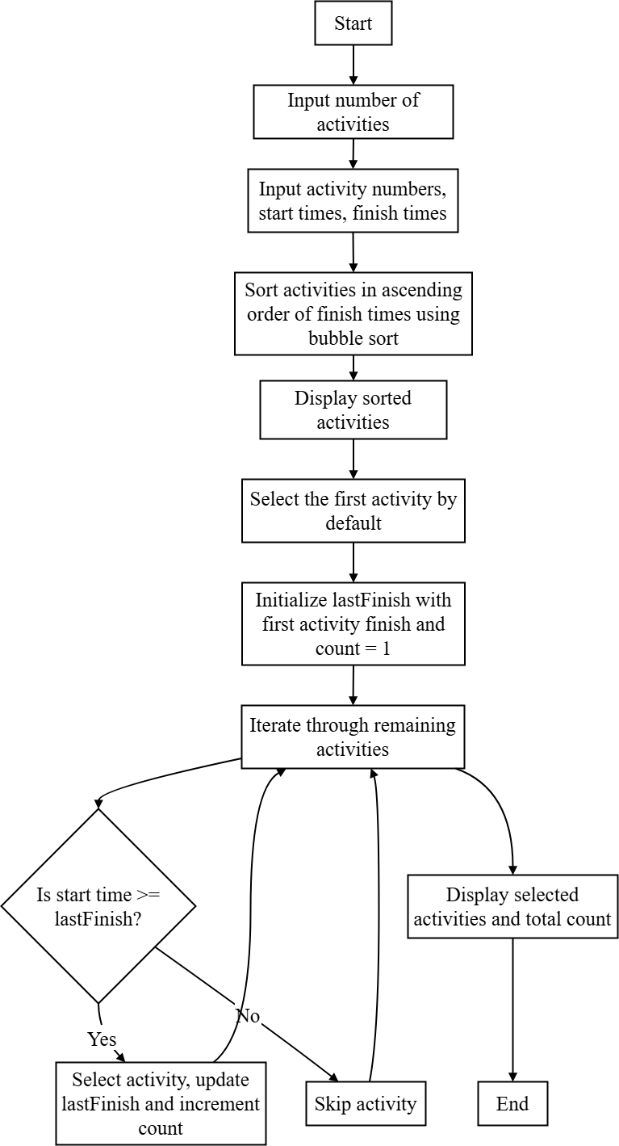
Code:
- #include <bits/stdc++.h>
- using namespace std;

- int main() {
- int n;
- cout << "Enter the number of activities: ";
- cin >> n;

- vector<int> activityNum(n);
- vector<int> start(n);
- vector<int> finish(n);

- cout << "\nEnter activity numbers: ";
- for (int i = 0; i < n; i++) {
- cin >> activityNum[i];
- }

- cout << "Enter start times: ";
- for (int i = 0; i < n; i++) {
- cin >> start[i];
- }

- cout << "Enter finish times: ";
- for (int i = 0; i < n; i++) {
- cin >> finish[i];
- }

- for (int i = 0; i < n - 1; i++) {
- for (int j = 0; j < n - i - 1; j++) {
- if (finish[j] > finish[j + 1]) {
- swap(finish[j], finish[j + 1]);
- swap(start[j], start[j + 1]);
- swap(activityNum[j], activityNum[j + 1]);
- }
- }
- }

- cout << "\n--- After sorting by finish time in ascending order ---\n";
- cout << "\nActivity\t";
- for (int i = 0; i < n; i++) {
- cout << activityNum[i] << "\t";
- }

- cout << "\nStart\t\t";
- for (int i = 0; i < n; i++) {
- cout << start[i] << "\t";
- }

- cout << "\nFinish\t\t";
- for (int i = 0; i < n; i++) {
- cout << finish[i] << "\t";
- }
- cout << endl;
- vector<int> selectedActivity;
- vector<int> selectedStart;
- vector<int> selectedFinish;

- selectedActivity.push_back(activityNum[0]);
- selectedStart.push_back(start[0]);
- selectedFinish.push_back(finish[0]);
- int lastFinish = finish[0];

- for (int i = 1; i < n; i++) {
- if (start[i] >= lastFinish) {
- selectedActivity.push_back(activityNum[i]);
- selectedStart.push_back(start[i]);
- selectedFinish.push_back(finish[i]);
- lastFinish = finish[i];
- }
- }

- cout << "\n--- Selected Activities (Maximum Set) ---\n";
- cout << "Number of activities selected: ";
- cout << selectedActivity.size() << "\n\n";
- cout << "Activity\tStart\tFinish\n";
- for (int i = 0; i < selectedActivity.size(); i++) {
- cout << selectedActivity[i] << "\t\t";
- cout << selectedStart[i] << "\t" << selectedFinish[i] << endl;
- }

- return 0;
- }
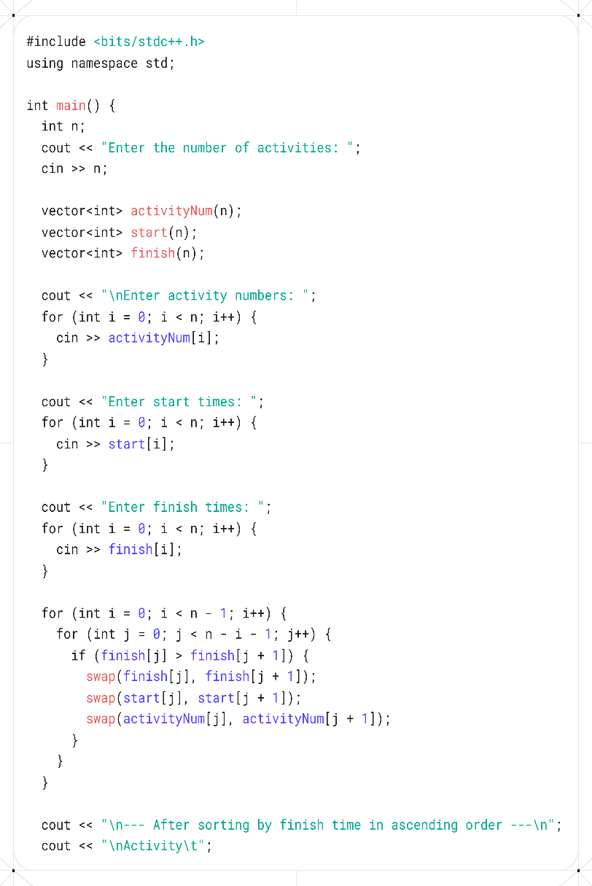
Screenshots:
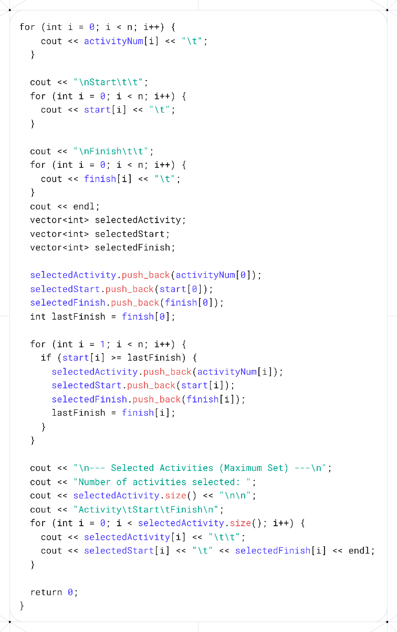

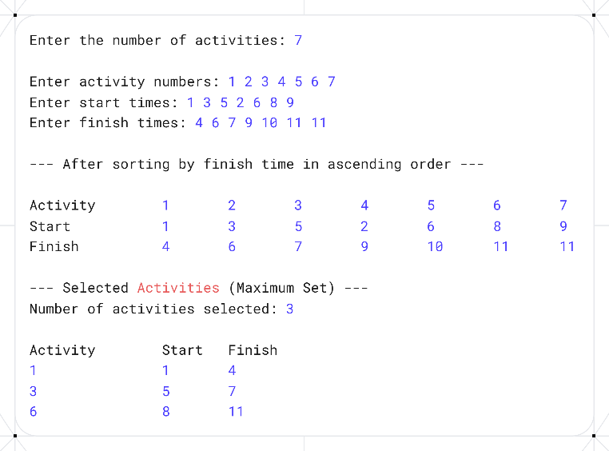

Analysis:
Data Set:
- Number of activities: 6
- Activity numbers: 1, 2, 3, 4, 5, 6
- Start times: 1, 3, 0, 5, 8, 5
- Finish times: 2, 4, 6, 7, 9, 9
Stepwise Execution (Greedy Selection by Earliest Finish Time):
- Sort activities by finish time ascending
  - Sorted order:
    - Activity 1 → 1–2
    - Activity 2 → 3–4
    - Activity 4 → 5–7
    - Activity 3 → 0–6
    - Activity 5 → 8–9
    - Activity 6 → 5–9
- Select activities
  - Select first activity: Activity 1 (1–2) → lastFinish = 2
  - Next, Activity 2 (3–4) → start >= 2 → select → lastFinish = 4
  - Next, Activity 4 (5–7) → start >= 4 → select → lastFinish = 7
  - Next, Activity 3 (0–6) → start < 7 → skip
  - Next, Activity 5 (8–9) → start >= 7 → select → lastFinish = 9
  - Next, Activity 6 (5–9) → start < 9 → skip
Final Output:
Activity Start Finish
1 1 2
2 3 4
4 5 7
5 8 9
Number of activities selected = 4

Complexity Analysis:
Time Complexity:
- Sorting activities by finish time (bubble sort): O(n²)
- Greedy selection loop: O(n)
- Overall: O(n²) due to bubble sort
Space Complexity:
- Arrays for activityNum, start, finish, selectedActivity, selectedStart, selectedFinish → O(n)
- Additional variables (lastFinish, count, loop counters) → O(1)
- Overall: O(n)
The greedy approach ensures the maximum number of non-overlapping activities. Sorting by finish time is crucial for correctness; selection itself is linear in time.

Conclusion:

